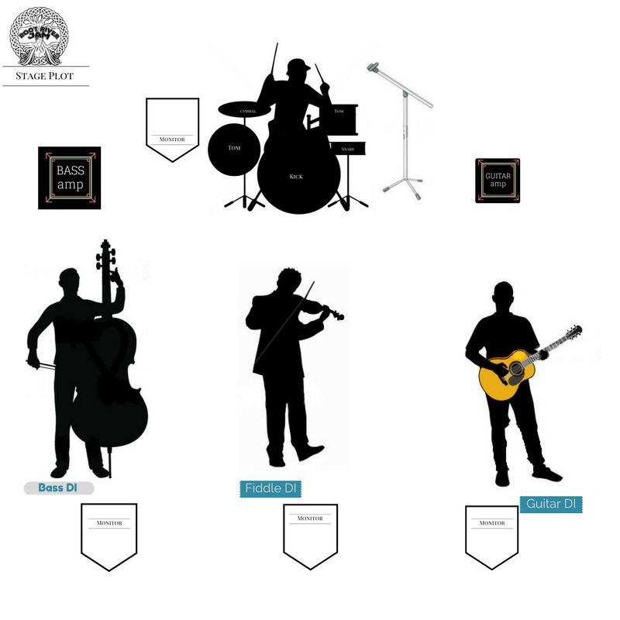

Technical rider Line set
3Vocal mics 1sm58 2 headsets(band provides)
1 DI Guitar (ped board player provides)no amp
1 DI Fiddle (player provides)
1 Upright Bass with (mic+amp player provides)
Drum jazz kit, 1 boom stand for vocal mic
MEMBERS
Dave acoustic guitar vocal headsetmic hardwire
Charlotte fiddle vocal headset mic hardwire
Blake upright bass
Miles Drums and vocal

