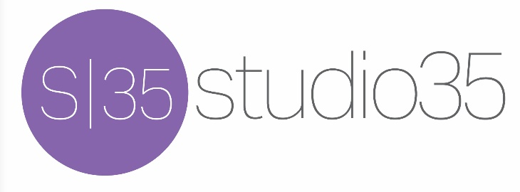

Tech and Hospitality Rider for Matt Jennings

Tech
Our tech set up is a guitar amp, bass amp and/or DI, drum set, and two vocal mics. Connect to house sound. Lighting can be a simple stage wash or whatever is available at the venue. We can discuss on show advance call.

Hospitality
Bottled water, coffee and assorted sodas and juice is greatly appreciated.

Pre-show dinner for each band member is also appreciated.

Thank you very much!
Questions? Contact Matt Jennings at mattjenningsmusic@gmail.com

