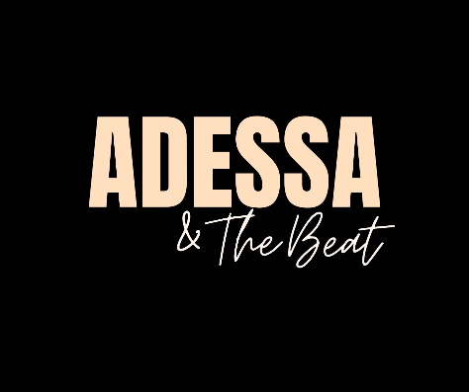

TECHNICIAN GUIDE – ADESSA & THE BEAT 5 PIECE VARIETY BAND
FOR ALL OUTDOOR, BOAT-IN AND REIF FIRESIDE VENUES:
PREMIX ALL VOCALS THROUGH ELECTROVOICE EVOLVE 30M SOUND SYSTEM AND XLR MONO SEND TO HOUSE
HOUSE MAY CONTROL INDIVIDUAL VOCAL VOLUMES, EQ, AND EFFECTS USING BAND’S IPAD IF REQUESTED
5 VOCAL MICROPHONES (WE TYPICALLY USE OUR OWN (SM58S) AND STANDS/CORDS)
DRUMS: ELECTRONIC KIT = DIRECT OUT (1/4) FROM DRUMMERS MONITOR/AMP AND NEED CAJON & SNARE MICS FOR OUTDOOR EVENTS
BASS: AMPLIFIER DIRECT OUT (XLR) - IF NEEDED FOR LARGER EVENTS OR MIC AMP
GUITAR: DIRECT OUT (1/4) FROM AMPLIFIER OR ACOUSTIC D.I. BOX OR USE AMP MICROPHONE
PIANO: DIRECT OUT (1/4) FROM PIANO OR AMPLIFIER TO MAIN MIX
WE TYPICALLY USE OUR EV SPEAKERS AS MONITORS BUT OCCASIONALLY NEED UP TO 3 SMALL WEDGE MONITORS ON STAGE. FOR FIRESIDE PERFORMANCES WE ARE SELF CONTAINED AND TYPICALLY NEED NO TECH SUPPORT OR EQUIPMENT.

TECHNICAL CONTACT: KEITH SORING 515 707 2982

