Kovan Baldwin
Tech & Hospitality Rider

Hospitality
Hot water with Lemon tea would be great. Pre-show hot meal is greatly appreciated. No dietary restrictions.

Accommodations: Two single hotel rooms in a Hampton Inn-type hotel or better is appreciated. Complimentary breakfast and wifi please.

Tech
In regards to the stage plot besides the sound set up I would need a mic stand and a stool.

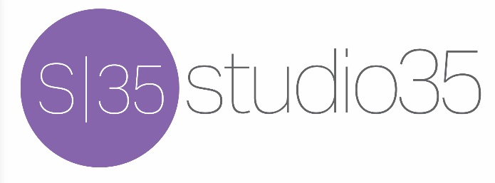
www.studio35music.com

