Roll On
The Music of Alabama

Tech and Hospitality Rider

Roll On is a 7 piece band consisting of a drummer, bass player, 2 guitar players, 1 keyboard player, acoustic guitar/fiddle player and a lead vocalist. All instrumentalists sing background vocals except the bass player and drummer.
Alabama prefers to play two 60 minute sets with a 30 minute intermission. Show and break length can be negotiated in more specific detail per each contract. Make checks payable to Tom Uecker.

TECH RIDER
Load in/Soundcheck:
- A minimum of 2 hours is required to load in, set up and sound check.
Equipment Requirements:
- Venue will provide all power cords.
- Venue will provide full PA and lights suitable for the venue size. Prior to signing the contract our tech will communicate about specific equipment needs that may be unique to each venue and get them written into the contract.
- Venue will provide a projector and screen to show images/videos while the band is performing.
- Stage inputs must be within 20’ of the stage
- Venue will provide sound and light tech for show.
- Sound check must be closed to the public and completed at least 30 minutes prior to doors opening.
Band Supplies:
- The band will provide their own instruments, personal amps, DI boxes and chords snakes, mics, mic stands.
- Band will bring their own IEM system and will mix their own monitors from stage and provide a splitter snake.
- Band will provide laptop and slide show, if appropriate for venue.

Stage Plot:
- Drum Riser (8x8) back of stage centered
- Keyboards each on a (5x5) riser located directly beside drum riser on each side.

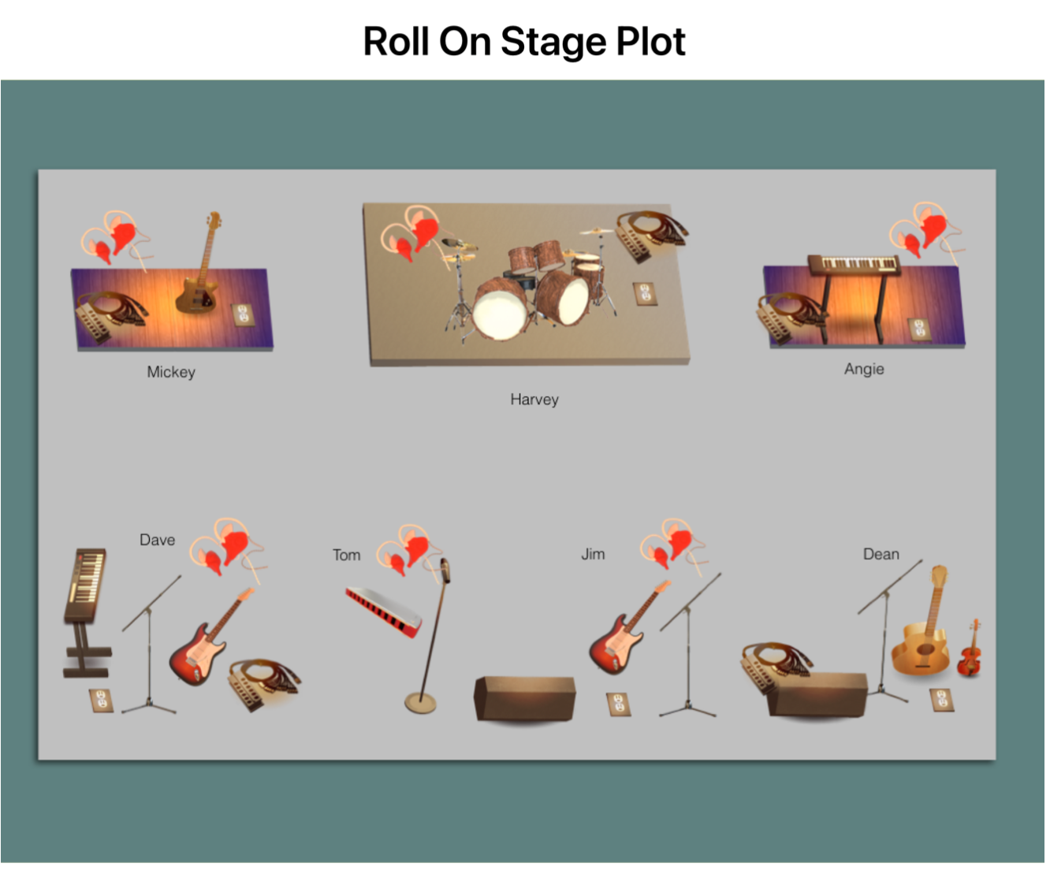

HOSPITALITY
Beverages:
- 2 cases of bottled water (not aquafina), one chilled, the other at room temperature.
- Assorted craft beers provided
- 1 case of Coors Light or other light beer
Food:
- Assorted sub sandwich tray or food voucher if the venue has a restaurant
Facilities:
- A clean, comfortable, and lockable dressing room should be available from the
point of load in for the duration of the event.
- A clean, comfortable and private room for the band to relax and eat prior to the show. Preferably near the bathroom and dressing room.
- A private bathroom for band use only.
Lodging:
If venue is greater than a 90 minute drive from the St. Cloud, MN, the venue will provide a minimum of seven hotel rooms for the band. This will be negotiated and specified in each individual contract.
Contact Info:
- Mickey Ironi @ 320-309-4940 -- Equipment/Tech
- Tom Uecker @ (320) 290-8484 -- General band info/website/advertisement

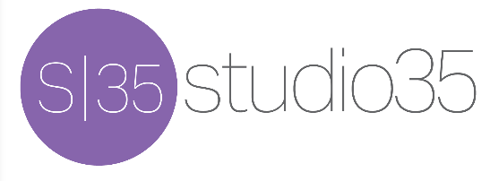
Sabrina Olson, Bookings 612.599.8673 booking@studio35music.com

