Jillian Rae

Jillian Rae is a fiercely unique spirit— a singer, songwriter, and multi-instrumentalist who cares more about making authentic music than about fitting into a tidy box. A classically trained violinist, she has become a commanding international presence, heading up her own critically acclaimed rock/pop band and creating powerful, genre-bending songs. She also performs regularly with her traditional folk band Corpse Reviver and has toured extensively, backing up Grammy-winning acts like The Okee Dokee Brothers.
Although she got her start playing with folk and country bands, Rae’s latest album I Can’t Be the One You Want Me to Be (2019) took a decided turn into pop and rock with unflinching, hard-hitting songs. It also showcased her orchestration abilities with layered violin tracks saturated in heavy grooves and moody arrangements. The album’s final track “Wayward One” was featured prominently in the hit Chinese film The White Storm 2 and has catapulted her into near stardom in China.
Lauded as a “triple threat on vocals, fiddle, and composition” (Star Tribune), Jillian Rae has become known for her soaring pop orchestrations and is an in-demand producer and session player. Along with her partner/co-producer Eric Martin, she runs a home studio in Minneapolis. During the pandemic, the studio became the hub for her weekly livestream performances and a space for her to write and record tracks for her next album. Never one to back down or give up, Rae is a natural-born performer who has always found a way to make music.
Raised in Minnesota’s Iron Range, Rae grew up playing in orchestras but fell in love early on with the traditional Scandinavian music she learned from her Finnish violin teacher. Equally influenced by her parent’s Jimi Hendrix record collection and polka music she inherited from her grandparents, she quickly learned how to adapt a variety of music to the instrument— putting her own spin on rock, folk, and classical music. Unsurprisingly, she studied music in college, touring with ensembles and performing in Vienna and London. After college, Rae relocated to Minneapolis where she became the go-to fiddler for a variety of folk and rock acts— joining The Brass Kings and backing up artists like Brian Just and Adam Levy (The Honeydogs, Turn Turn Turn). While making a name for herself as a top-notch fiddler and a singer with a powerful stage presence, she formed her own band and started performing her original mix of Americana, rock, and pop.
In 2013, Rae released her debut album Heartbeat— a confident pop-rock record with subtle nods to her folk and classical pedigrees. A glimmer of what was to come on her wide-ranging recordings, the album showed her playing country fiddle on one tune, rock guitar on the next, and driving violin through synthy guitar effects on another. The album garnered much praise and made artists and promoters take notice. She became so busy touring and recording with various projects that she wasn’t able to get back into the studio to make her own music until 2016 when she recorded her EP Wanderlust (2017). More of a stripped-down Americana record, it showcased Rae’s dynamic vocals and serious songwriting chops that served as a portend of what was to come.
In addition to writing, recording, and performing, Rae is an experienced music educator. She has kept a studio of private students for more than two decades, something she has continued online during the pandemic. Although music takes up most of her time, she always makes time to cook, hang out with her handsome dog Ernie, and keep tabs on the latest Bigfoot sightings and paranormal activity.

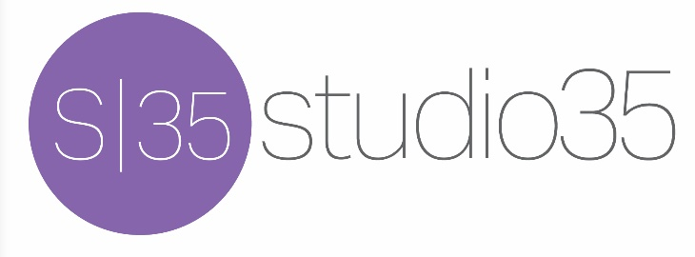
Studio35music.com

